**Project Planning Phase**

**Project Planning Template (Product Backlog, Sprint Planning, Stories, Story points)**

| Date | 18 October 2022 |
| --- | --- |
| Team ID | PNT2022TMID43213 |
| Project Name | Project - Real-Time Communication System Powered by AI for Specially Abled |
| Maximum Marks | 8 Marks |

**Product Backlog, Sprint Schedule, and Estimation (4 Marks)**

Use the below template to create product backlog and sprint schedule

| **Sprint** | **Functional Requirement (Epic)** | **User Story Number** | **User Story / Task** | **Story Points** | **Priority** | **Team Members** |
| --- | --- | --- | --- | --- | --- | --- |
| Sprint-1 | Data Collection | USN-1 | Collect Dataset | 8 | High | V Logesh,  Vishnu |
| Sprint-1 |  | USN-2 | Image preprocessing | 8 | Medium | Vallarasu S,  Raj Krishna |
| Sprint-2 |  | USN-3 | Import the required libraries, add the necessary layers and compile the model | 9 | Low | Vallarasu S,  Vishnu |
| Sprint-1 |  | USN-4 |  | 10 | Medium | Vallarasu S,V Logesh |
| Sprint-1 | Login | USN-5 | As a user, I can log into the application by entering email & password | 8 | High | Vishnu,  Raj krsihna |
|  | Dashboard |  |  |  |  | Vallarasu S,  Raj Krishna |
|  |  |  |  |  |  | V Logesh,  Vishnu |
|  |  |  |  |  |  | V Logesh,  Vishnu |

**Project Tracker, Velocity & Burndown Chart: (4 Marks)**

| **Sprint** | **Total Story Points** | **Duration** | **Sprint Start Date** | **Sprint End Date (Planned)** | **Story Points Completed (as on Planned End Date)** | **Sprint Release Date (Actual)** |
| --- | --- | --- | --- | --- | --- | --- |
| Sprint-1 | 20 | 6 Days | 24 Oct 2022 | 29 Oct 2022 | 20 | 29 Oct 2022 |
| Sprint-2 | 20 | 6 Days | 31 Oct 2022 | 05 Nov 2022 |  |  |
| Sprint-3 | 20 | 6 Days | 07 Nov 2022 | 12 Nov 2022 |  |  |
| Sprint-4 | 20 | 6 Days | 14 Nov 2022 | 19 Nov 2022 |  |  |
|  |  |  |  |  |  |  |
|  |  |  |  |  |  |  |
|  |  |  |  |  |  |  |
|  |  |  |  |  |  |  |

**Velocity:**

Imagine we have a 10-day sprint duration, and the velocity of the team is 20 (points per sprint). Let’s calculate the team’s average velocity (AV) per iteration unit (story points per day)

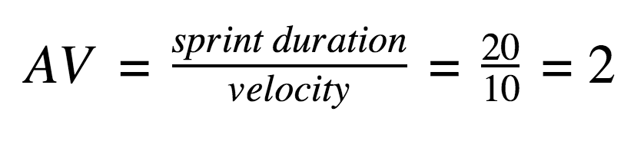

**Burndown Chart:**